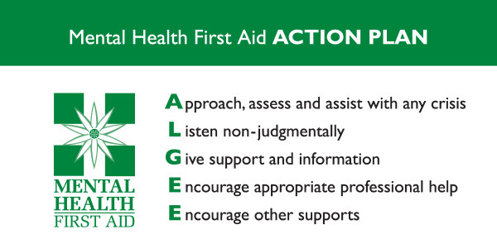
Mind your language - terminology is important when talking about mental health or dealing with someone who is experiencing a mental health condition. What may be appropriate language for clinicians may be less helpful for employers or job seekers. For the purposes of this resource, we generally use the phrase 'mental ill health' or ‘mental health issue’ to describe the distress someone is experiencing.
We avoid the term 'mental health problems' deliberately: we don't want to suggest to employers and others that someone experiencing mental ill health is necessarily a problem to themselves or to anyone else. Someone may have a mental health condition, either chronic or fleeting, but still enjoy wellbeing: the two are not incompatible.
In this sense (as in most senses) our mental health is no different from our physical health. Someone with a lifelong, long-term or fluctuating mental health condition may experience an acute phase that requires them to take time off from work for treatment or recuperation. At this point we refer to them as 'unwell'.
Many more people experience symptoms of distress – for example, sleeplessness, irritability or poor concentration, loss of or increased appetite, higher alcohol consumption – without having a diagnosable mental health condition. The key differences between the two categories are the severity and duration of the symptoms and the impact they have on everyday life.
Usually, a GP will be involved in diagnosing conditions and in prescribing or advising on treatment. But a clinical diagnosis doesn't dictate what an individual can or can't do; indeed, the way people experience and live with their mental health, along with the level of support they need, varies from person to person.
Everyone should have the opportunity to work, whatever their mental health. Mental ill health is common and most of us will either experience it, have experienced it, or know someone else who has experienced it. Mental ill health touches us all and should not be a barrier to treating people fairly, with respect and understanding.
The most helpful approach for you is to try to understand the mental health issues a person is facing, but then put these in the context of their strengths and capabilities. That involves talking to them in order to get a clear understanding of what they can do, rather than what they can’t do – which is the same strengths-based approach you would adopt for any member of staff or learner.
Early warning signs of mental ill health
Here's a list of behaviours and warning signs to watch out for.
- Not getting things done – missing deadlines or forgetting tasks.
- Erratic or unacceptable behaviour.
- Irritability, aggression, tearfulness.
- Complaining about the workload.
- Being withdrawn and not participating in conversations or out-of-work activities.
- Increased consumption of caffeine, alcohol, cigarettes and/or sedatives.
- Inability to concentrate.
- Indecision.
- Difficulty remembering things.
- Loss of confidence.
- Unplanned absences.
- Arguments/conflicts with others.
- Increased errors and/or accidents.
- Taking on too much work and volunteering for every new project.
- Being adamant they are right.
- Working too many hours – first in, last out/emailing out of hours or while on holiday.
- Being louder or more exuberant than usual.
- Negative changes to ways of working or socialising with colleagues.

Physical signs might include the following.
- Constant tiredness.
- Sickness absence.
- Being run down and frequent minor illnesses.
- Headaches.
- Difficulty sleeping.
- Weight loss or gain.
- Lack of care over their appearance.
- Gastrointestinal disorders.
- Rashes/eczema.

Recognising someone’s difficulties at an early stage makes it easier to help them and provide appropriate support. Investing time and effort in promoting the mental and physical wellbeing (the two are linked) of staff and learners will be repaid many times over in terms of enhanced morale, engagement, loyalty and productivity.

Sources of information:

https://mhfaengland.org/individuals/adult/

