Apprentice Extra Card

NUS Apprentice extra provides discounts in-store and online at your favourite brands to help your hard earned cash go a little further. They have been created by the National Union of Students (NUS), and so the money they raise selling the discount card helps to fund the National Society for Apprentices, which will serve to represent your needs and those of all vocational learners.
For just £11 for 1 year and £19 for 2 years - you get discounts from the likes of The Co-op, Amazon, Dominos, Alton Towers, New Look and much more!
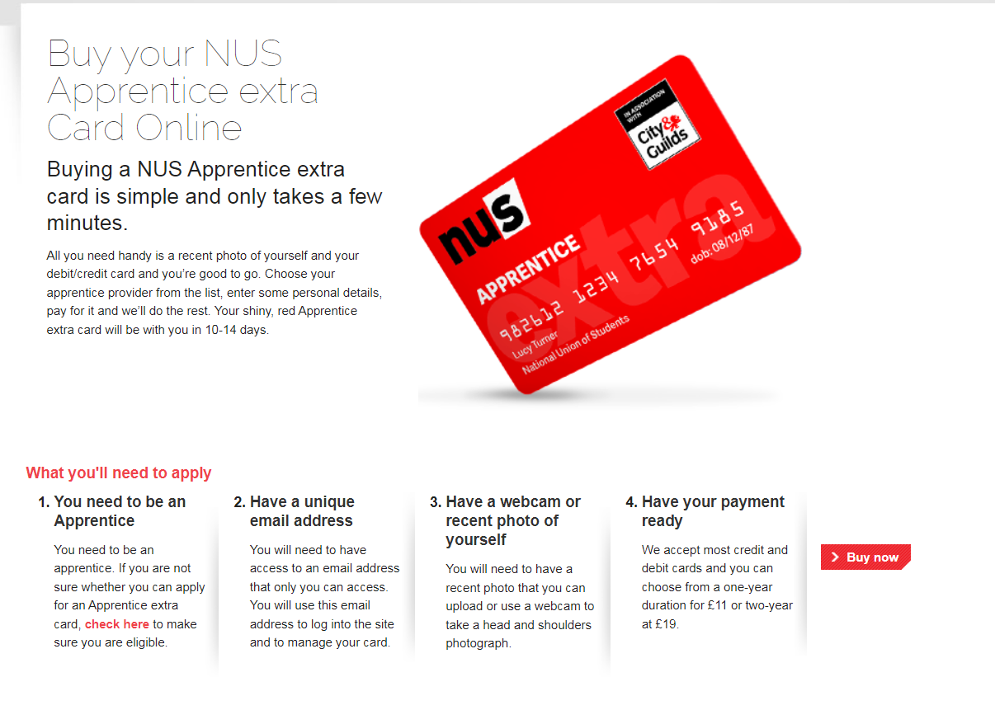https://www.apprenticeextra.co.uk/

With thanks, ITEC NE

