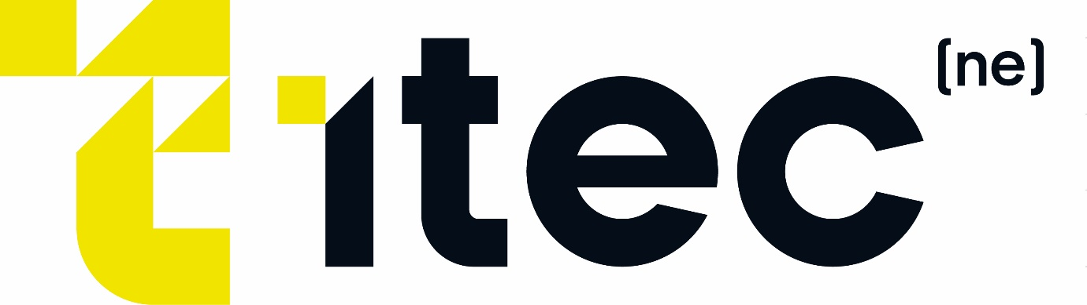

Overview of Household Support Fund and Cost of Living Support
Sources of information:
Cost of living support: Overview - GOV.UK (www.gov.uk)
Cost of Living Payments 2023 to 2024 - GOV.UK (www.gov.uk)
Help with your energy bills: Overview - GOV.UK (www.gov.uk)
Financial help if you're disabled: Overview - GOV.UK (www.gov.uk)

Cost of Living Support Overview
These payments are not taxable and will not affect the benefits or tax credits you get

Low income benefits and tax credits Cost of Living Payment
You may be entitled to up to 3 Cost of Living Payments of £301, £300 and £299 if you get any of the following benefits or tax credits on certain dates:
- income-based Jobseeker’s Allowance (JSA)
- income-related Employment and Support Allowance (ESA)
- Income Support
- Pension Credit
- Universal Credit
- Child Tax Credit
- Working Tax Credit
The payment will be made separately from your benefit payments.
You will not get a payment if you are only getting New Style ESA, contributory ESA, or New Style JSA.
If you have a joint claim on the qualifying dates, a single payment of £301, £300 and £299 will be sent using the same payment method used between these dates, if you’re eligible.

£301 Cost of Living Payment eligibility

Universal Credit
You are eligible for the first Cost of Living Payment of £301 if you were entitled to a payment (or later found to be entitled to a payment) of Universal Credit for an assessment period that ended in the period 26 January 2023 to 25 February 2023.

Income-based JSA, income-based ESA, Income Support and Pension Credit
You are eligible for the first Cost of Living Payment of £301 if you were entitled to a payment (or later found to be entitled to a payment) of income-based JSA, income-related ESA, Income Support or Pension Credit for any day in the period 26 January 2023 to 25 February 2023.
You are also eligible if you are entitled to one of these benefits for any day during this period but you do not receive a benefit payment because your entitlement is between 1 penny and 9 pence.

Tax credits
You are eligible for the first Cost of Living Payment of £301 if you received a payment of tax credits for any day in the period 26 January 2023 to 25 February 2023, or you are later found to have been entitled to a payment for this period.

£300 and £299 Cost of Living Payments
This guidance will be updated with the qualifying dates for the £300 and £299 Cost of Living Payments when they have been announced.

When you will not be eligible: ‘Nil awards’
You will not be eligible for the Cost of Living Payment if your benefit is reduced to £0 for the qualifying period. This is sometimes called a ‘nil award’.
For example, if you get Universal Credit, reasons your benefit may be reduced to £0 include getting more than one payment of earnings, your or your partner’s earnings go up, your or your partner’s savings go up, you start getting another benefit.
If money has been taken off for other reasons (such as payments of rent to your landlord or for money that you owe), you might still be eligible.

When you’ll be paid
If you’re entitled, you will get:
- £301 paid between 25 April 2023 and 17 May 2023 for most people on DWP benefits
- £301 paid between 2 and 9 May 2023 for most people on tax credits and no other low income benefits
- £300 paid during autumn 2023 for most people
- £299 paid during spring 2024 for most people
If you’re getting both Child Tax Credit and Working Tax Credit, you will receive a Cost of Living Payment for Child Tax Credit only, which will be paid by HMRC.
If you’re getting tax credits from HMRC and a low income benefit from DWP, you cannot get a Cost of Living Payment from both HMRC and DWP. You will usually be paid by DWP only.
Your payment might come later, for example if you’re awarded a qualifying benefit at a later date or you change the account your benefit or tax credits are paid into. You will still be paid the Cost of Living Payment automatically.
If you have received a Cost of Living Payment, but we later find that you were not eligible for it, you may have to pay it back.
This guidance will be updated with the payment dates before each payment starts.
Disability Cost of Living Payment

Disability Cost of Living Payment
You may be entitled to a Disability Cost of Living Payment of £150 if you get any of the following benefits on a certain date:
- Attendance Allowance
- Constant Attendance Allowance
- Disability Living Allowance for adults
- Disability Living Allowance for children
- Personal Independence Payment
- Adult Disability Payment (in Scotland)
- Child Disability Payment (in Scotland)
- Armed Forces Independence Payment
- War Pension Mobility Supplement
This guidance will be updated with the qualifying date for the payment when it has been announced.
If you were getting a qualifying benefit from the Ministry of Defence and a qualifying benefit from DWP, you will get a Disability Cost of Living Payment from DWP only.

When you’ll be paid
Most people will be paid the £150 Disability Cost of Living Payment during summer 2023.
This guidance will be updated with the payment dates before the payments start.
Payments will be made to people who were getting a qualifying disability from DWP before payments to people who were getting a qualifying benefit from the Ministry of Defence.
Your payment might come later, for example if you’re awarded a qualifying benefit at a later date or you change the account your benefit or tax credits are paid into. You will still be paid the Cost of Living Payment automatically.
Energy

Energy Bills Support Scheme
You can get a £400 discount to help with your energy bills for winter 2022 to 2023. This is called the Energy Bills Support Scheme.
You’ll usually get the discount automatically - you do not have to apply.
If you have a traditional prepayment meter, you’ll get the discount in the form of credit or a voucher to use at a top-up point. Smart meters get it automatically.
Find out more about the Energy Bills Support Scheme.

